**Assignment No- 2**

1)Write a program that checks if a given year is a leap year or not using both if-else and switch-case.

Code :

**public** **class** LeapYear {

**public** **static** **void** main(String[] args) {

**int** year=2024;

**if**(year%4==0) {

System.***out***.println("Leap Year:"+year);

}**else** **if**(year%400==0) {

System.***out***.println("Leap Year: "+year);

}**else** {

System.***out***.println("Not a Leap Year");

}

}

}

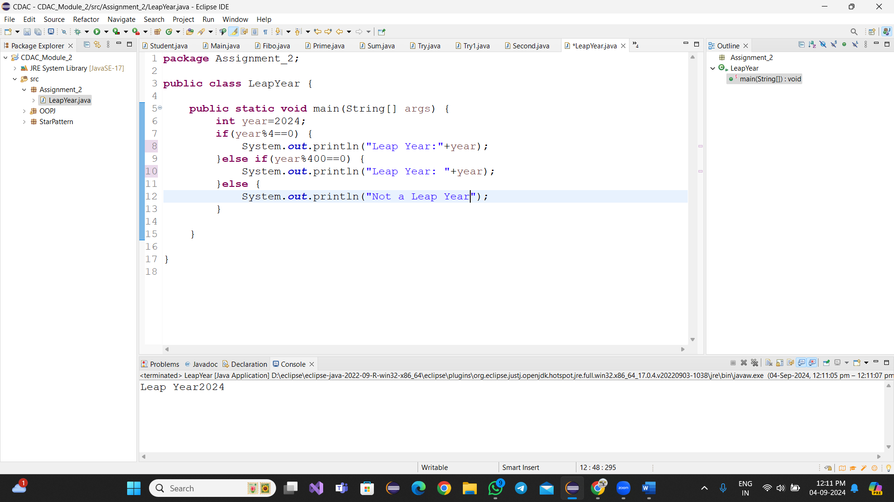

Using Switch-case

Code: **import** java.util.*;

**public** **class** StarPattern {

**public** **static** **void** main(String[] args) {

**int** year = 2024;

**boolean** isLeap = **false**;

**switch** (year % 4) {

**case** 0:

**if** (year % 100 == 0) {

**if** (year % 400 == 0) {

isLeap = **true**;

} **else** {

isLeap = **false**;

}

} **else** {

isLeap = **true**;

}

**break**;

**default**:

isLeap = **false**;

}

**if** (isLeap) {

System.***out***.println(year + " is a leap year.");

} **else** {

System.***out***.println(year + " is not a leap year.");

}

}

}

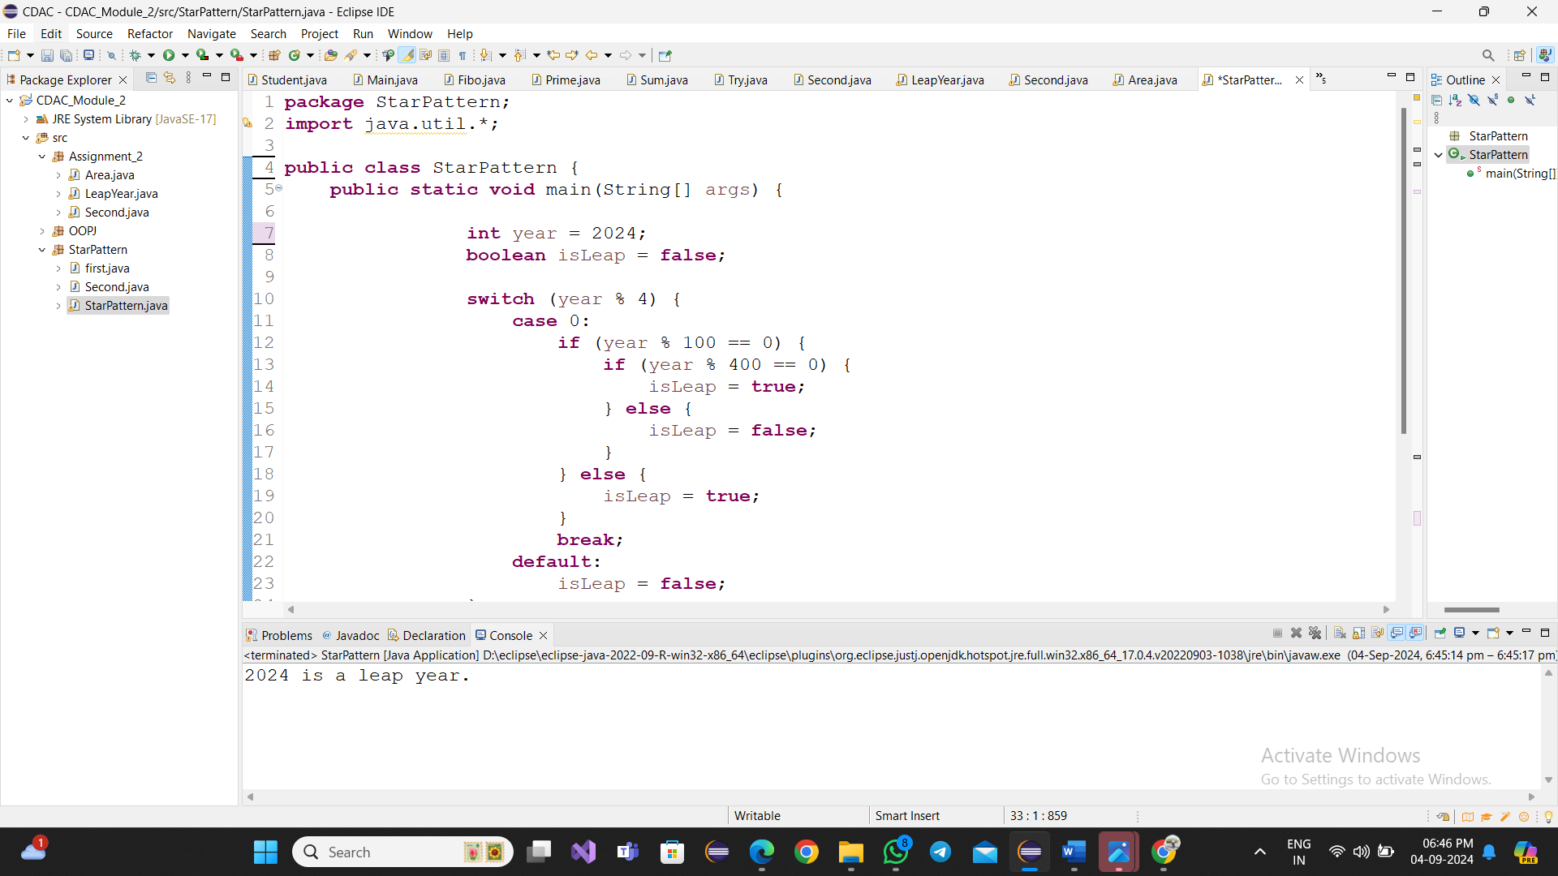

2)Implement a program that calculates the Body Mass Index (BMI) based on height and weight input using if-else to classify the BMI int categories (underweight, normal weight, overweight,etc).

Code:

**import** java.util.*;

**public** **class** Second {

**public** **static** **void** main(String[] args) {

Scanner sc=**new** Scanner (System.***in***);

System.***out***.println("Enter your weight in kg");

**int** weight=sc.nextInt();

System.***out***.println("Enter your Height in meters");

**float** height=sc.nextInt();

**double** bmi=weight/(height*height);

**if**(bmi<15) {

System.***out***.println("Your are underweight");

}**else** **if**(bmi>=15 && bmi<25) {

System.***out***.println("Your are normalweight");

}**else** **if**(bmi>=25 && bmi<30) {

System.***out***.println("Your are overweight");

}**else** {

System.***out***.println("you are not fit..!");

}

}

}code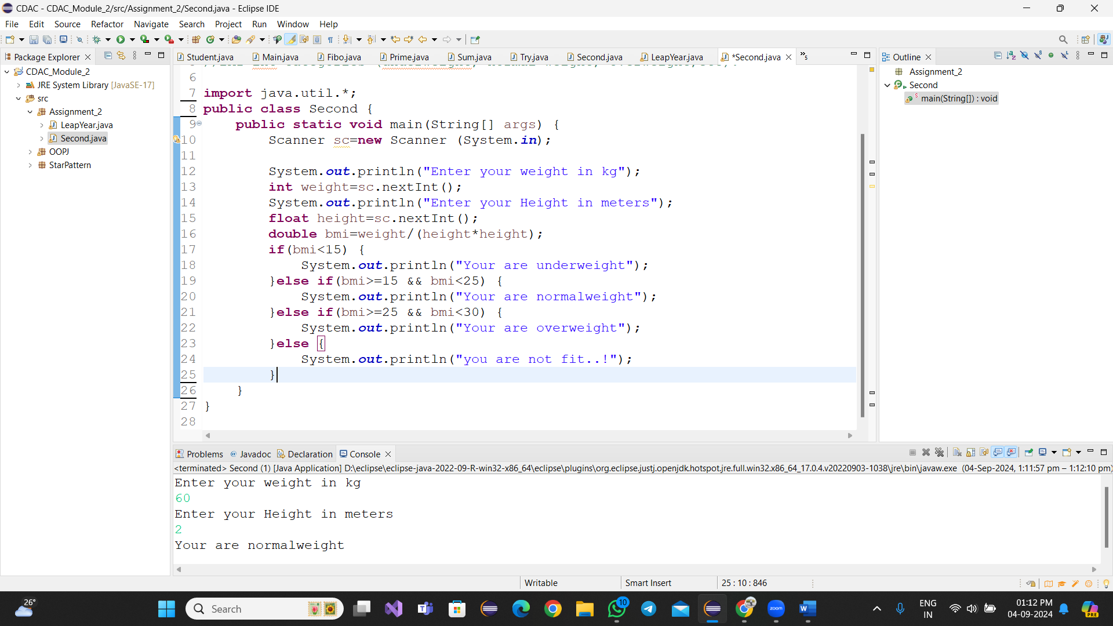

3)Write a program that checks if a person is eligible to vote based on their age.

Code:

**import** java.util.*;

**public** **class** Second {

**public** **static** **void** main(String[] args) {

Scanner sc=**new** Scanner (System.***in***);

System.***out***.println("Enter your age");

**int** age=sc.nextInt();

**if**(age>=18) {

System.***out***.println("Your are Eligible for Voting..!");

}**else** { System.***out***.println("you are not Eligible for Voting..!");

}

}

}

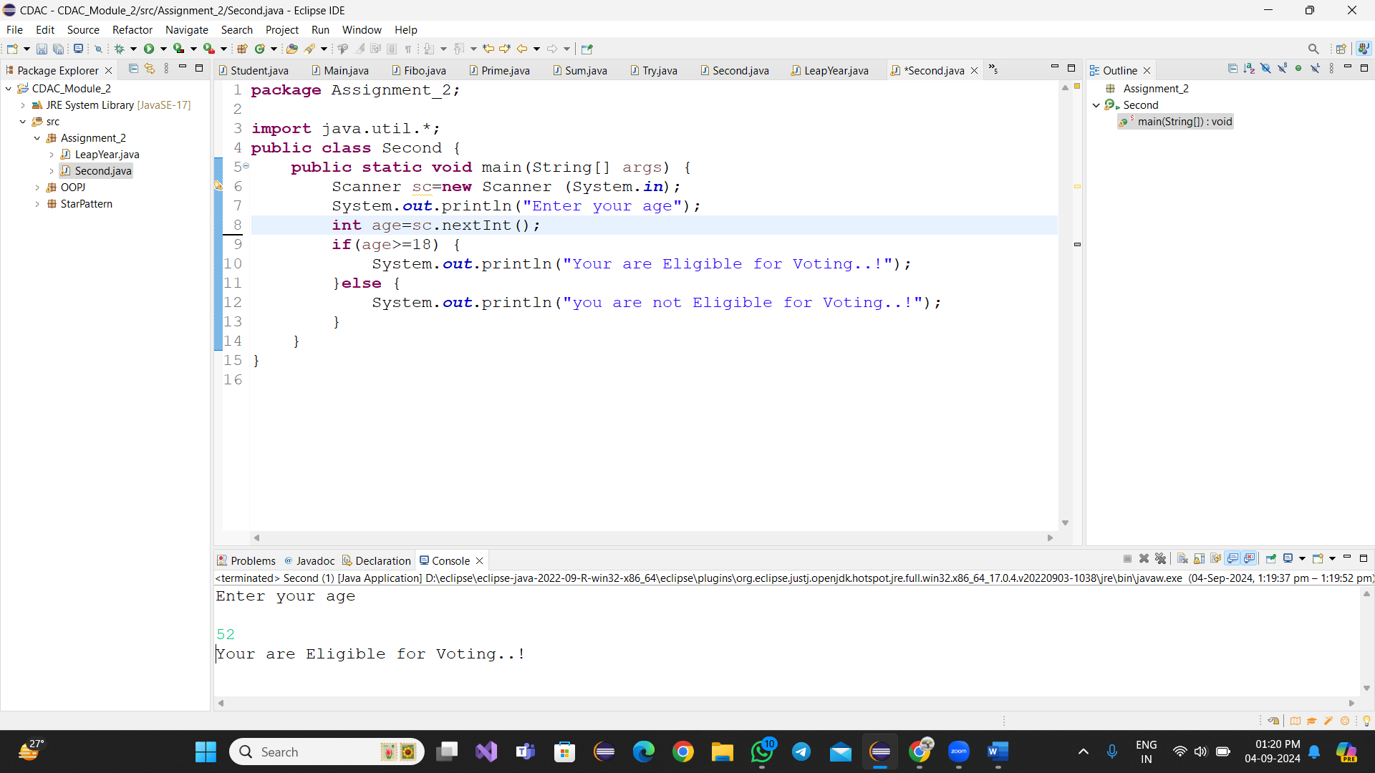

4)Write a program that takes a month (1-12) and prints the corresponding season (Winter, Spring, Summer, Autumn) using a switch case

Code:

**import** java.util.*;

**public** **class** Second {

**public** **static** **void** main(String[] args) {

Scanner sc=**new** Scanner (System.***in***);

System.***out***.println("Enter the month");

**int** month=sc.nextInt();

String season;

**switch**(month) {

**case** 12:

**case** 1:

**case** 2:

season="Winter";

**break**;

**case** 3:

**case** 4:

**case** 5:

season="spring";

**break**;

**case** 6:

**case** 7:

**case** 8:

season="sunny";

**break**;

**case** 9:

**case** 10:

**case** 11:

season="Autumn";

**break**;

**default** :

season="Invalid month";

**break**;

}

System.***out***.println("The Season is: "+season);

}

}

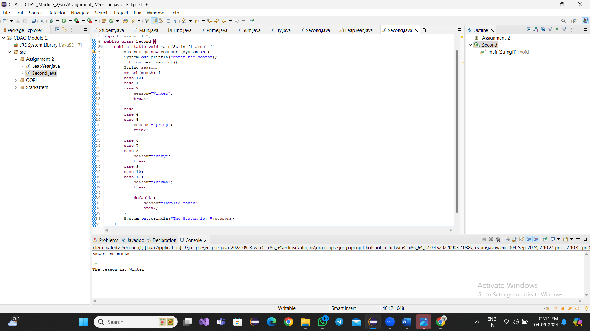

5)Write a program that allows the user to select a shape (Circle, Square, Rectangle, Triangle) and then calculates the area based on user-provided dimensions using a switch case.

Code:

**import** java.util.*;

**public** **class** Area {

**public** **static** **void** main(String[] args) {

Scanner scanner = **new** Scanner(System.***in***);

System.***out***.println("Select a shape to calculate the area:");

System.***out***.println("1. Circle,2.Square,3.Rectangle,4.Triangle");

System.***out***.print("Enter your choice: ");

**int** select = scanner.nextInt();

**double** area = 0;

**switch** (select) {

**case** 1:

System.***out***.print("Enter the radius of the circle: ");

**double** radius = scanner.nextDouble();

area = 3.14* radius * radius;

**break**;

**case** 2:

System.***out***.print("Enter the side length of the square: ");

**double** side = scanner.nextDouble();

area = side * side;

**break**;

**case** 3:

System.***out***.print("Enter the length of the rectangle: ");

**double** length = scanner.nextDouble();

System.***out***.print("Enter the width of the rectangle: ");

**double** width = scanner.nextDouble();

area = length * width;

**break**;

**case** 4:

System.***out***.print("Enter the base of the triangle: ");

**double** base = scanner.nextDouble();

System.***out***.print("Enter the height of the triangle: ");

**double** height = scanner.nextDouble();

area = 0.5 * base * height;

**break**;

**default**:

System.***out***.println("Invalid choice. Please select a valid shape.");

**return**;

}

System.***out***.println("The area is: " + area);

}

}

